Fahmi Fardiyan Arief, S.T
Perum Ciomas Permai Blok D13 No. 7
Kel. Ciapus, Kec.Ciomas, Kab. Bogor
Mobile : +6282297491650

CURRICULUM VITAE

Personal Details
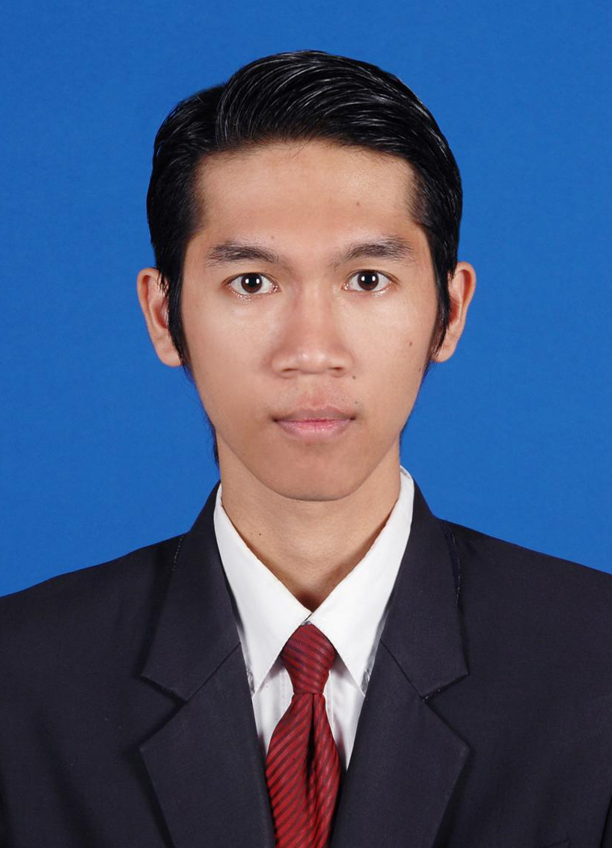
Full Name : Fahmi Fardiyan Arief, ST
Sex : Male
Place, Date of Birth : Kuningan, 30 April 1985
Nationality : Indonesia
Marital Status : Merried
Height, Weight : 170 cm, 55 kg
Religion : Moslem
Address : Ciomas Permai Blok D13 No. 7, Kel. Ciapus, Kec.
Ciomas, Kab. Bogor
Phone : +62 822 7749 1650
E-mail : ffardiyan@gmail.com

Education Backgound
- Formal
1991 – 1996 : SD Negeri 5 Kuningan
1996 – 1999 : SMP Negeri 2 Kuningan
1999 – 2002 : SMU Negeri 3 Kuningan
2002 – 2007 : Electrical Engineering Dept. at Ahmad Dahlan University Yogyakarta

- Non-Formal
  - Computer & Internet Course at LPK Prodata, Kuningan
  - Visual Basic 6.0 Course at Magistra Utama, Yogyakarta
  - English Language Course at Nusantara Training Center, Yogyakarta
  - Mikrocontroller AVR ATMega 8535 Course at LPK Inkubator Teknologi, Yogyakarta
  - Mikrocontroller 68HC11 Training at Ahmad Dahlan University, Yogyakarta

Qualifications
- Electrical Engineering Skills
- Computer Literate, Software (OS. Windows, Ms. Office, Visio, Photoshop) & Hardware
- Internet Literate

Experience
- Organisation
2002 -- 2003 A member of Ikatan Pelajar dan Mahasiswa Kuningan (IPMK) Yogyakarta
2003 – 2004 A Secretary of UAD’s Radio Station (RAMADA FM)
2004 – 2005 A Member of HMTE (Himpunan Mahasiswa Teknik Elektro) UAD Jogja
- Working
- Decison Staf at PT Bank Syariah Mandiri on Jan 2015 on Jan 2016 – Jun 2016
- Account Maintenance at PT Bank Syariah Mandiri on Jan 2015 – Jan 2016
- Sales Assistant & IT Representatif at PT Bank Syariah Mandiri on May 2010 – Dec 2014
- A Staff Patent, Design & Copyright Dept. at Law Office General Patent International on February 18, 2008 – Dec 2009.
- Freelance as a Sales Support Mitra (SSM) at PT. Excelcomindo Pratama Tbk. Yogyakarta on August – Dec 2008.
- An Apprentice for the Instrumentation Dept. At PT. Madubaru Madukismo Yogyakarta on September – Oktober 2005.
- Worked as Assistant at Ahmad Dahlan University Laboratory in 2004 – 2006.

